Hi Ravi,

Hope you are doing good. We had a ruff patching last weekend with migrated servers. Even though we tried to implement the details of DAN, for performing the patching we had several issues with the EC2 Systems manager.

Run Command:

* Run Command is timing out – when we are trying to hit on larger targets, we are not getting the accurate output. For example when I am trying to hit scans for 150 servers its only showing 50.
* When we are running the scans for large targets, we not getting expected several failed status failed, and which are not showing the outputs.
* Some Instances are always in progress state forever, and not passing the scans, they do the same thing on patch day.
* In Run command, when series of Tasks are executing in Maintenance windows the tasks are dependent on each other, i.e. Another task will not start until the above task is completed. Is that same behavior of Ec2 Systems Manager?

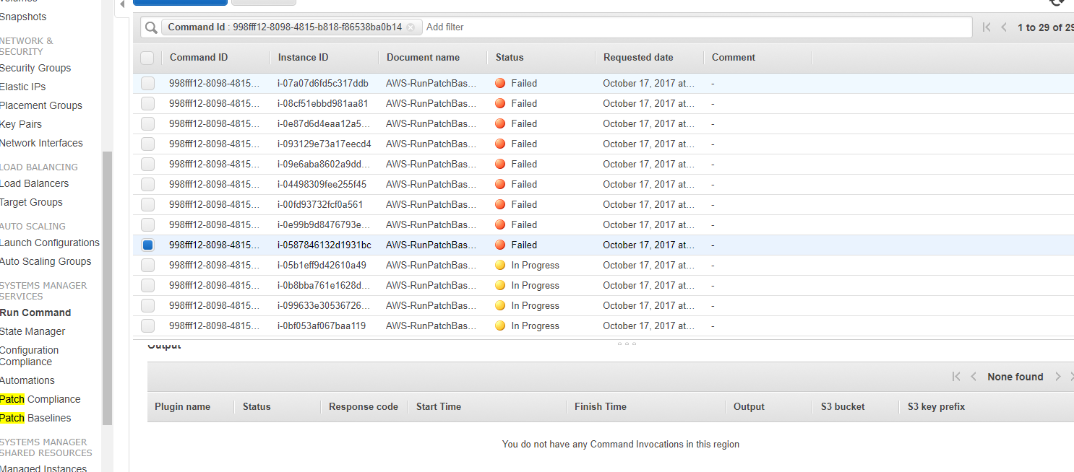

* **After speaking with DAN, he was focusing on Ec2config installing for 2003- 2012 servers, but that seem to working,**
* **When I raised a Ticket to support regarding some above issues, they were saying update the SSM agent, and If that does not work login in to the server and restart the agent. But, that did not work for many Servers.**

**Maintenance window:**

* We saw this error, with the maintenance windows for last patch cycle. It states that windows execution limit exceeded.

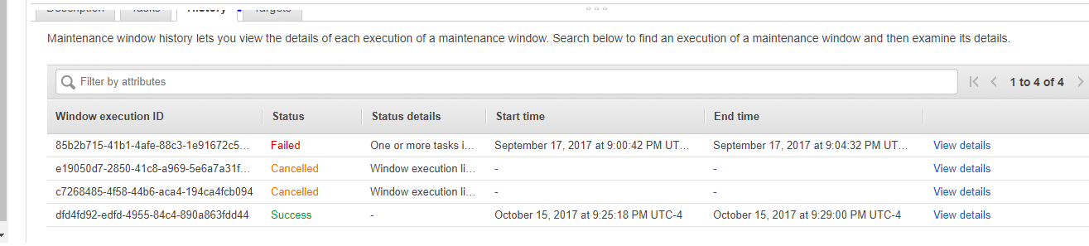

* Some servers are showing output as not expected. Please see the below output.

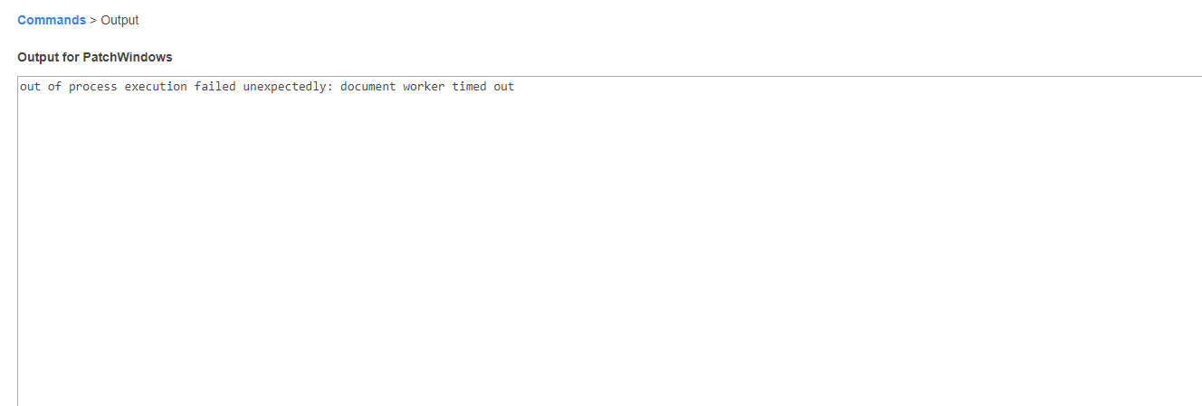

* Many servers are showing status as In progress even after the patching is completed.

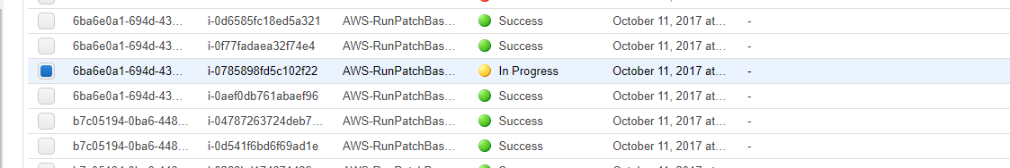

**Patch Compliance**:

* As we track down the patching details through Patch compliance, we are not getting accurate results.

Even though we had some failed servers, we patched them through run command so, according to the functionality of run command it should update the Compliance summary, however we are able to see that.

Windows Lift and shift servers:

I know from the support that for windows lift and shift servers(2003-2012) they need SSM agents, rather installing EC2 Config.